Reusable MAsk
Washable mask
Update : 21/02/2020

Why?
- Because predictions that inexpensive, disposable masks likely would be in short supply if a pandemic develops in the near future (1).
- Once the pandemic has become established, it will be impossible to provide negative pressure rooms for all Covid-19 patients. Therefore, we will need to focus on interrupting the routes associated with most spread (ie, through droplet precautions and hand hygiene) (2).
- Masks decrease both the number of virus-laden droplets inhaled or deposited onto the mucous membranes and our ability to touch our nose and mouth and self-inoculate the virus (2).

Remarks
- For individuals without respiratory symptoms, a medical mask is not required, as no evidence is available on its usefulness to protect non-sick persons (3).
- No mask is fail-safe, and its effectiveness depends on fit, level of exposure, and appropriate use (1).
- The mask doesn’t give total protection against transmission through direct contact. Hand washing is necessary when using and after removing masks (1).
- Medical masks are likely to provide far less protection against aerosols than filtering facepiece respirators, but may offer better protection than woven masks, homemade alternatives, or no protection at all (1).
- People should not engage in activities that would increase their risk of exposure to flu just because they have a mask or respirator (1).
- If masks are used (single-use or washable masks), best practices should be followed on how to wear, remove, and dispose of them and on hand hygiene action after removal (3). In the event of a pandemic, advise to wear a facemask should be accompanied by appropriate public education and communication strategies to increase rates of proper usage and compliance by the public (1).
- Washable masks could be recommended for individuals with respiratory symptoms (3). For relatives or caregivers to individuals with suspected COVID-19 infection with mild respiratory symptoms when they are in the same room with the affected individual (3).
- History : Usual use of washable masks until the arrival of the sterile single-use non-woven fabric in 1980 (7). During winter 2007/2008 in Beijing, on 400 HWC of 8 hospitals, 60 % were wearing washable, reusable cotton-yarn mask (8). Anecdotal evidence has showed that handmade masks of cotton gauze were protective in military barracks and in HCW during the Manchurian epidemic (pneumonic plague, 1911, China) (9).

Cons
- Cloth (e.g. cotton or gauze) masks are not recommended under any circumstance by WHO (3).
- There is currently no simple, reliable way to decontaminate these devices and enable people to use them safely more than once (1).
- Their use may give users a false sense of protection that could encourage risk-taking (1).
- Not recommended for HCW.

Pros
- In the absence of any alternative, some members of the public may improvise respiratory protection out of t-shirts, scarves, or other cloth. Given the lack of sufficient data either supporting or refuting the effectiveness of woven cloth masks and improvised coverings in blocking influenza transmission, the committee (on the Development of reusable facemasks during an influenza pandemic, USA 2006) hesitates to discourage their use, but cautions that they are not likely to be as protective as medical masks or respirators (1).
- Better alternative than the wrong alternatives (single-use masks that are washed or boiled) that people might use in case of shortage of masks by the population (5).
- Offering a washable mask to the population may reduce public panic, might be a solution to sudden increases in consumption and might limit the shortage of single-use masks for HCW’s (6).

- To be researched
Which masks? For who? For what purpose? Which washing condition?
Which manufacturer? Supply time? Budget?
How masks could be distributed to the population?
Any actual experience in another country?

Washable mask in the press

Press :
New antiviral masks from Israel may help stop deadly coronavirus, 28 January 2020
https://www.israel21c.org/new-antiviral-masks-from-israel-may-help-stop-deadly-virus/

Coronavirus: Hong Kong textile industry producing nearly 3,000 handmade reusable fabric masks amid acute shortage of face coverings, 10 February 2020
https://www.scmp.com/news/article/3049737/coronavirus-hong-kong-textile-industry-producing-nearly-3000-handmade-reusable
Guarding against the coronavirus, sustainably: are reusable face masks the answer ?, 18 February 2020
https://www.eco-business.com/news/guarding-against-the-coronavirus-sustainably-are-reuseable-face-masks-the-answer/

Commercial links

Commercial links with no guarantee of effectiveness and no mass production:
https://www.etsy.com/search?q=washable%20mask
https://www.amazon.com/reusable-mask/s?k=reusable+mask
https://www.facebook.com/anyafacemasks/
https://www.ebay.com/sch/i.html?_nkw=reusable%20face%20mask
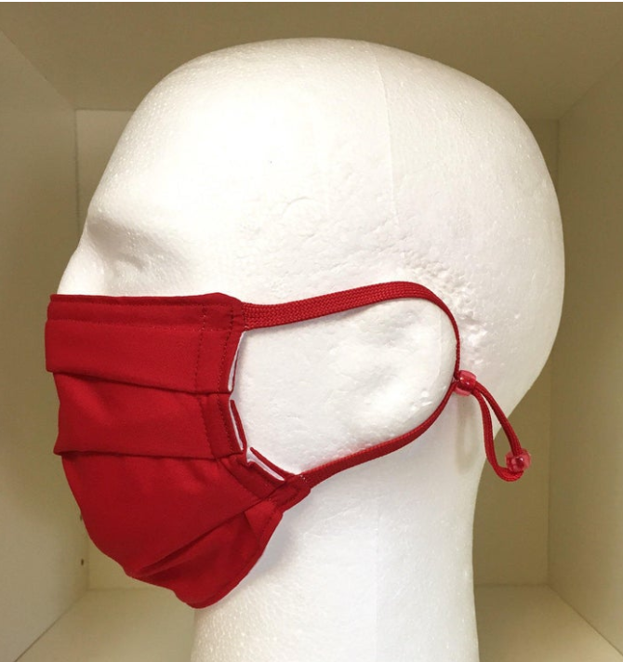 | LillyDesign : Washable Medical Face Masks 8.29 €  USA.  Two breathable layers: 100% cotton print outside, and 70% bamboo 30% cotton blend lightweight jersey knit on the side that touches the face.
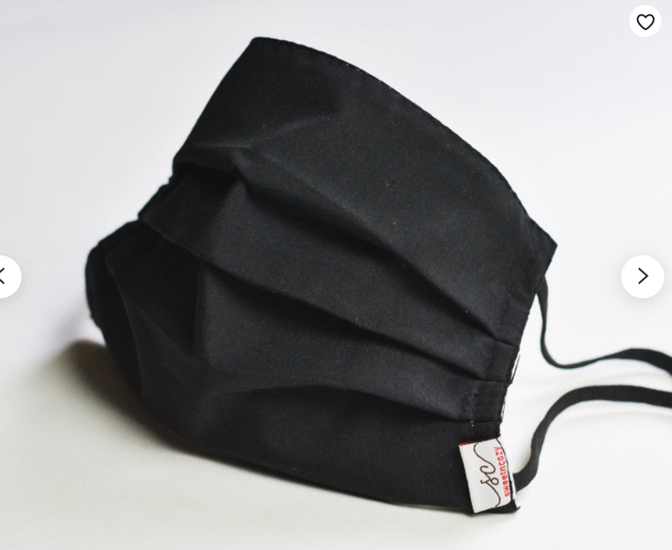 | SweetnCozycreations : FaceMask / surgical Mask 12.19 €  Malaysia.  2 layers of fabric cotton with flexible plastic nose wire.  Children (14cm X 8.5cm expendable up to 14 cm in height)  Adult (17cm X 10 cm expendable up to 18 cm in height)  Pre wash before use, gentle hand wash or machine wash.

References

1. Reusability of Facemasks During an Influenza Pandemic [Internet]. [cited 2020 Feb 11]. Available from: http://www8.nationalacademies.org/onpinews/newsitem.aspx?RecordID=s04272006
2. Collignon PJ, Carnie JA. Infection control and pandemic influenza. Med J Aust. 2006 Nov 20;185(10):S54.
3. Advice on the use of masks the community, during home care and in health care settings in the context of the novel coronavirus (2019-nCoV) outbreak [Internet]. [cited 2020 Feb 11]. Available from: https://www.who.int/publications-detail/advice-on-the-use-of-masks-the-community-during-home-care-and-in-health-care-settings-in-the-context-of-the-novel-coronavirus-(2019-ncov)-outbreak
4. Yao B, Wang Y, Ye X, Zhang F, Peng Y. Impact of structural features on dynamic breathing resistance of healthcare face mask. Sci Total Environ. 2019 Nov 1;689:743–53.
5. Mackenzie D. Can ANY mask really protect you from the coronavirus? [Internet]. Mail Online. 2020 [cited 2020 Feb 11]. Available from: https://www.dailymail.co.uk/health/article-7955701/As-people-resort-using-bras-grapefruit-mask-really-protect-coronavirus.html
6. Coronavirus: Hong Kong textile industry making thousands of reusable masks [Internet]. South China Morning Post. 2020 [cited 2020 Feb 11]. Available from: https://www.scmp.com/news/article/3049737/coronavirus-hong-kong-textile-industry-producing-nearly-3000-handmade-reusable
7. Fischer L. L’habit du chirurgien en salle d’opération : 100 ans d’histoire [Internet]. [cited 2020 Feb 11]. Available from: https://www.biusante.parisdescartes.fr/sfhm/hsm/HSMx1998x032x004/HSMx1998x032x004x0353.pdf
8. Mask-wearing and respiratory infection in healthcare workers in Beijing, China - ScienceDirect [Internet]. [cited 2020 Feb 11]. Available from: https://www.sciencedirect.com/science/article/pii/S1413867011701532
9. Dato VM, Hostler D, Hahn ME. Simple Respiratory Mask. Emerg Infect Dis. 2006 Jun;12(6):1033–4.

